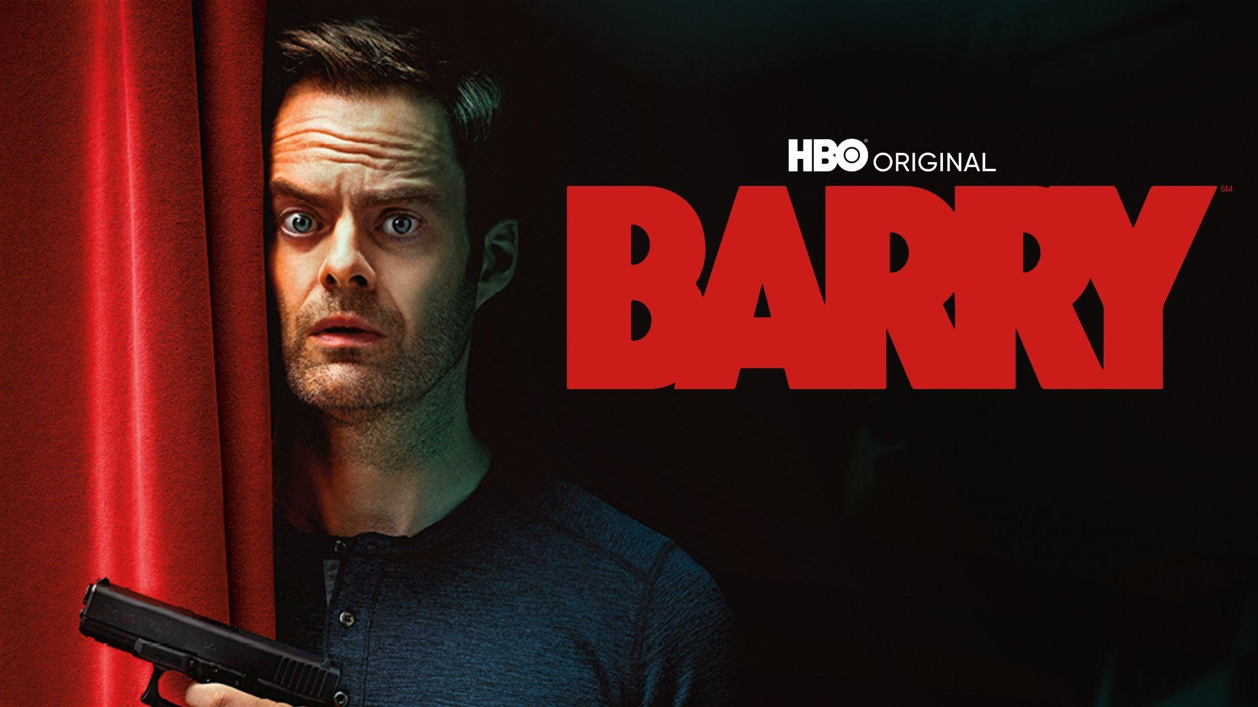

Loglines
A-Story
An aimless but deadly hitman, BARRY, gets assigned a new hit, and attempts to complete the task.
B - Story
Barry discovers acting and must decide if acting is his purpose.
C- Story (Runner)
NoHo Hank, a quirky gangster, wants Ryan, a struggling actor sleeping with his boss’s girlfriend, dead.

Synopsis
A - Story
BARRY is an aimless but deadly hitman. Contemplating his purpose, Barry is given a new assignment from Fuchs, his job connect and friend. Barry goes to LA and meets NoHo Hank, an almost too friendly gangster, to give him his assignment. Barry finds when and where to kill his next mark, Ryan. After a series of detours, Barry and Ryan end up working together – as actors. By the end of the night, Barry and Ryan are almost friends. Unfortunately, NoHo Hank has been following Barry and is displeased with Barry and Ryan’s friendship. Fuchs shows up the next day and presses Barry he must kill Ryan. “This is what you do. This is who you are.” Barry regroups and finds Ryan – ready to kill – when he discovers Ryan is already dead - shot from a nearby car. Barry sees the killers and asks, “What’s going on? As he approaches the car, the killers try to kill Barry, but they are too slow reloading, and Barry kills them.
B- Story
After killing his latest victim, Barry contemplates his life and takes his time going back to his normal life. Once he does, his hitman contact Fuchs admonishes him for it before giving Barry a new assignment. Barry tries to talk to Fuchs about his purpose – but Fuchs already has another job.
On his new hit job, Barry stumbles on Sally rehearsing. Confused and intrigued, Barry follows Sally into the acting studio and watches Sally fail and then kill her monologue. As he’s watching Sally, Ryan (his hit) asks if Barry could help him out with his monologue. Barry doesn’t know what to do – but helps Ryan (badly). When it’s done, Sally asks Barry to come out with the actors. Barry refuses at first, but Sally convinces him otherwise. At the bar, Barry meets the rest of the acting crew, but Sally is centerstage – he likes her. Before he leaves, she asks him to take Ryan home. Barry agrees. When Barry drops Ryan off, he and Ryan have a talk about acting. Ryan seems like a nice enough guy and he actually listens to and encourages Barry about acting (something Fuchs did not). At the end of the conversation, he and Ryan hug it out.
The next day Barry is informed he was seen hugging Ryan and his job is to kill him. Barry attempts to tell Fuchs about acting, and maybe it’s his purpose. Fuchs tells him it isn’t and to do his job. Barry agrees but before he does, he goes to see Gene, the acting coach, and get his opinion. When Gene tells Barry he is awful because he’s not honest. Barry gives up and tells Gene everything. But Gene believes it’s a monologue and sees ‘the truth.’ in it. He invites Barry to the studio.
At the end of the night, Barry meets a waitress and asks what’s in her hand. She says a script, and then says, “I’m an actor” in which Barry replies, “Me too.”
C- Story
NoHo Hank hires Barry to kill Ryan. Ryan is an actor who is sleeping with NoHo Hank’s boss girlfriend. After he shows Barry who to kill, he follows Barry to see if Barry is doing his job when he discovers Barry and Ryan hugging it out. NoHo Hank tells Fuchs but decides Barry can’t be trusted and kills Ryan themselves. When Barry discovers this, NoHo Hank and his armed man try to kill Barry but fail.

Beatsheet
A- Story
- Barry doing his job, then contemplates his job.
- Barry gets a new assignment from Fuchs.
- Barry goes to LA. Meets NoHo Hank and gets a picture of the hit.
- Barry stalks Ryan.
- Ryan asks Barry to help with his monologue. Barry agrees.
- Barry and Ryan share a moment. Hug.
- Barry gets reprimanded for his time with Ryan.
- Barry refocuses and finds Ryan… dead.
- Barry sess NoHo Hank and someone else. They killed Ryan already, and they try to kill Barry, but Barry kills them first.

B-Story
- Barry meets Sally and follows her into the studio.
- Barry tries to leave, but Sally asks him out.
- Barry gets to know the actors and falls for Sally.
- Sally asks Barry to take Ryan home.
- Barry talks to Ryan.
- Barry tries to talk to Fuchs but fails.
- Barry talks to Gene.
- Barry tells the waitress he’s an actor.

C-Story
- NoHo Hank asks Barry to kill Ryan.
- NoHo Hank follows Barry and sees Barry and Ryan together.
- NoHo Hank doesn’t trust Barry, and kills Ryan themselves.

The Grid Breakdown
TEASER  (A)Barry does his job, then contemplates his job.  (B)Barry takes his time getting back to his normal life. | ACT ONE  (A)Fuches admonishes Barry, then gives him a new assignment.  (B)Barry tries to talk to Fuches about his purpose. Fuches already has another job.  LA  (A&C)Barry meets NoHo Hank, an almost too friendly gangster.  (C)Ryan is sleeping with Hank's boss's girlfriend.  (A&C)Hank shows Barry who to kill: Ryan. | ACT TWO  (A)Barry stalks Ryan. Finds when and where to kill him.  (B)Barry stumbles on Sally rehearsing. Confused. Intrigued.  ACTING STUDIO  (B)Barry follows Sally in. Watches her fail, then kill her monologue.  (A&B)Ryan asks Barry to help with his monologue.  (A&B)Barry doesn't know what to do. Helps. Badly. | ACT THREE  (B)Sally asks Barry to come out with the actors. He refuses. She convinces him.  THE BAR  (B)Barry meets the acting crew. Sally is centerstage. He likes her.  (B)Sally asks Barry to take Ryan home. Barry agrees.  DROPPING RYAN OFF  (A&B)Barry and Ryan talk about acting. Ryan listens and encourages him. Something Fuches did not.  (A)Barry and Ryan hug it out.  (C)NoHo Hank has been following Barry. He sees the hug. | ACT FOUR  NEXT DAY  (C)NoHo Hank tells Fuches.  (A&B)Barry is told to kill Ryan. Tries to tell Fuches acting might be his purpose. Fuches: “This is what you do. This is who you are.”  (B)Before he does, Barry sees Gene. Gene: he's awful because he's not honest.  (B)Barry tells Gene everything. Gene thinks it's a monologue. Sees the truth. Invites him to the studio.  (C)Hank decides Barry can't be trusted.  (A&C)Barry finds Ryan, ready to kill. Ryan is already dead. Shot from a nearby car.  (A&C)“What's going on?” The killers are too slow reloading. Barry kills them.  END OF THE NIGHT  (B)A waitress with a script: “I'm an actor.” Barry: “Me too.”  Ends on (B)

