FVM 2032 TV PILOT

A Simple and Short History of Television
- Even before radio was conceived, television technology was invented in 1897 by Ferdinand Braun when he invented the cathode ray tube (CRT).
- 1907 was the first time the cathode ray tube was used to produce images.
- The first televisions were sold in late 1920s in the US, UK, and Russia but only scanned at 30 lines so the picture quality and sales were poor.
- NBC and CBS were the first to transmit broadcasts; in New York in 1930’s using a transmitter on top of the Empire State Building. But almost no one owned TV’s at this point.
- July 1st, 1941 the FCC authorized commercial broadcasting and NBC had the first televised commercial with a shaky,
10 second Bulova watch commercial that aired before a Brooklyn Dodgers, Philadelphia Phillies baseball game.
- On December 7th, 1941 Pearl Harbor was attacked and was the first major news story broken on television.
- While its’ technology and popularity were dormant during WWII, television sales picked up, about three years after the end of WWII, starting in 1948.
- .05% of US households had a television in 1946, 55.7% in 1954, and 90% by 1962.
- In 1954 RCA introduced a color television set but they (affordability) didn’t become popular until about 1964.
- By 2000 a billion televisions had been sold.

Television to you

Television had a rough start. Besides the bad technology and cost, the first issue with television was that it lacked the talent to create consistently entertaining shows. The most talented entertainers and producers were still working on Broadway and radio.
Still, viewers had a sense of “astonishment and glamour” in the infancy of television.
It wasn’t until the 1950’s, The Golden Age (1948 – 1959), that TV really took off. TV networks tried a lot of different programs: live shows, variety shows (vaudeville), comedy shows, dramas, and whodunits.
It is called the Golden Age because everything associated with television was new and changing; for example, the (situational comedy) or sitcom was created. News, sports, and politics figured out its role in TV during this time.
There is said to be a re-emergence of a Golden Age of television right now. With so many network, cable, streaming, and internet channels available – the viewer and creator have a bundle of choices.
Unlike film, where there are maybe 200 minor-to-major releases per year, television offers a bundle of opportunities to write big, small, and audience-specific shows.
Pilot scripts are the thing right now. Agents, managers, producers, showrunners, competitions, and fellowships want to read your pilots.
Spec scripts used to be the primary way to get into TV, now it’s more about the pilots.
Because of this, I think you should all consider your pilot as an introduction to you, your ability, and your writing style. You should, by the time you leave this program, have 2-3 pilots written. In other words, don’t let this pilot be your last.
Lastly…
ACCORDING TO THE WGA (WRITER’S GUILD OF AMERICA) IN 2019
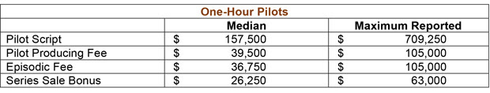
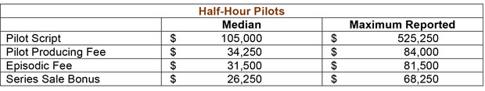

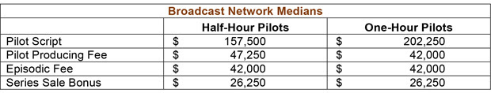

TV NOW

Broadcast TV
- Ad-supported, free, over-the-air TV plus cable (58 million)
- CBS, FOX, NBC, WB
- MTV, TNT, Comedy Central, BET, Hallmark, OWN, ESPN
- 40.3% (and dropping) of all TV usage in the US in June 2024

Free Ad-Supported Streaming TV (FAST)
- Free, ad-supported streaming TV
- Linear, scheduled programming similar to cable but without feels or contracts
- A $9 billion market in 2024
- Pluto TV (80 million+)
- Tubi (80 million+)
- Roku Channel (83.6 million)
- Freevee (80 million)
- Xumo (40 million)

Advertising-Based Video On Demand (AVOD)
- Ad-supported and on-demand
- Host proprietary libraries of studio-licensed moves and shows.
- Most FAST add AVOD’s becoming a hybrid of the two.

Subscription Video On Demand (SVOD)
- Subscription-based.
- Netflix (277.65 million worldwide)
- Disney+ (153.8 million)
- Max (99.6 million)
- Prime (200 million worldwide)
- Hulu (50.2 million)
- Apple+ (25 million)

Transactional Video On Demand (TVOD)
- Pay per view. Download to rent.

- For more on American TV History = Click Here
- Media Pay Report from Deadline Article = Click Here

